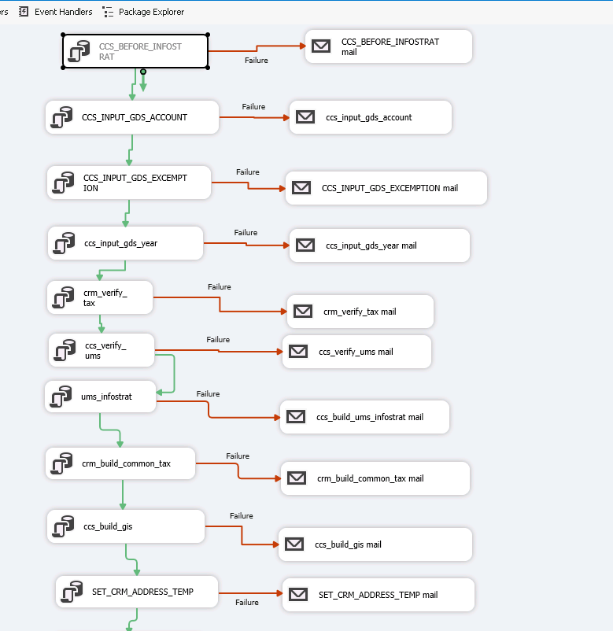

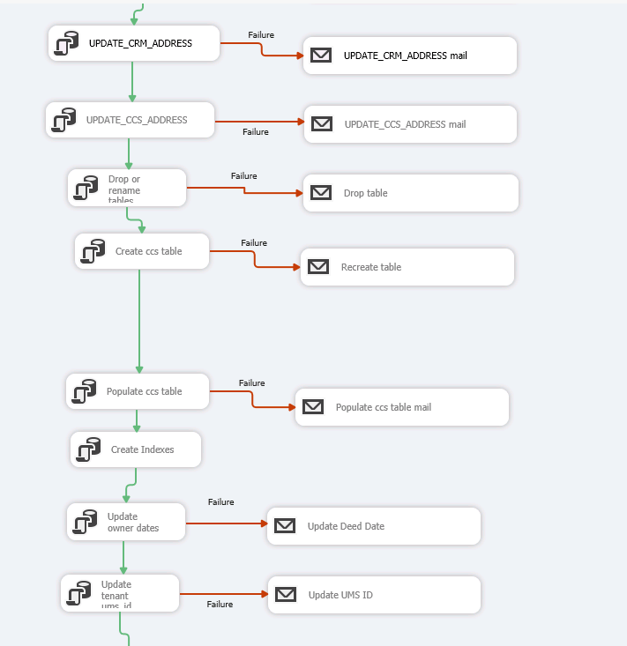

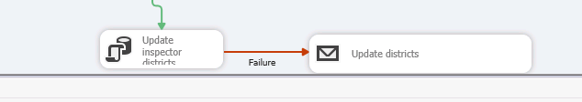

1. CCS_BEFORE_INFOSTRAT on Geoprod1 – garland.ccs_before_infostrat
   1. Calls garland.rebuild_base_tables then drops and recreates synonym garland.RULE on garland.adr_resolve_rules_infostrat
2. CCS_INPUT_GDS_ACCOUNT on Geoprod1 – garland.ccs_input_gds_account – truncates garland.gds_account, inserts into this table from gds_taxaccounts from gdstax_new (GIS on cog-sqldbs3)
3. CCS_INPUT_GDS_EXCEMPTION on geoprod1 – garland.ccs_input_gds_exemption – TRUNCATES GARLAND.gds_exemption, inserts into this table from dbo.GDS_TaxExemptionRecords on gdstax_new
4. Ccs_input_gds_year on geoprod1 – garland.ccs_input_gds_year – truncates garland.GDS_YEAR, inserts into this table from dbo.GDS_TaxRecords@GDSTAX_NEW
5. Crm_verify_tax – on geoprod1 – garland.crm_verify_tax – truncates garland.AdrResult_Input, inserts into this table from garland.gds_account, garland.gds_year.   
   Calls: garland.adrResult_PRE_EDIT_INPUT; Reads reacords in garland.adrResult_Input Updates records in garland.adrResult_Input based on hard coded values  
   calls: garland.SCRUB_ADDRESS;   
   Calls: garland.SCRUB_ADDRESS_Prep_Input; truncates garland.gis_app_rowID then inserts into this table from garland.adrResult_input  
    garland.SCRUB_ADDRESS_Resolve; truncates table garland.gis_verify_addr then calls garland.Resolve_Address_batch_driver garland.SCRUB_ADDRESS_Fix_AdrResult; - address spaces in the address
6. Ccs_verify_ums - on geoprod1 – garland.ccs_veify_ums  
   inserts into garland.adrResult_Input select * from garland.CCS_Verify_UMS_View  
   deletes from garland.adrResult based on rec_seq  
   inserts into garland.adrResult_banner select * from garland.adrResult
7. Ums_infostrat - on geoprod1 – garland.ccs_build_ums_infostrat
8. Crm_build_comman_tax – on geoprod1 garland.crm_build_common_tax
9. Ccs_build_gis – on geoprod1 – garland.ccs_build_gis
10. SET_CRM_ADDRESS_TEMP – on geoprod1 - - crm_address_pkg.set_crm_address_temp()
11. UPDATE_CRM_ADDRESS on geoprod1 - CRM_ADDRESS_PKG.UPDATE_CRM_ADDRESS();  
    updates garland.crm_address on newgeoprod
12. DISABLED - UPDATE_CCS_ADDRESS
13. DISABLED Drop or rename tables
14. DISABLED Create ccs table
15. DISABLED Populate ccs table
16. DISABLED Create Indexes
17. DISABELD Update owner dates
18. DISABLED Update tenant ums_id
19. DISABLED Update inspector districts

